POWER BI – WRITE UP

Tejashwini Saravanan
School of Business, Government, and Economics
Seattle Pacific University
ISM 6361 - Data Visualization
Ryan C. LaBrie, Ph.D.
MAY 29, 2024- Wednesday
Spring 2024

DRUG SALES ANALYSIS



DATA SET SOURCE: KAGGLE https://www.kaggle.com/datasets/emrahaydemr/drug-sales-data

HYPERLINK FOR MY PROJECT – POWER BI PUBLIC SITE
https://app.powerbi.com/groups/me/reports/0f04ca36-d93e-4f18-9a47-534007db1c23/8064d05a297d9223196c?experience=power-bi

INTRODUCTION

The pharmaceutical industry plays a crucial role in providing essential medications to improve global health. Analysing sales data within this industry can offer valuable insights into market trends, consumer behaviour, and product performance that drive informed decision-making. In this analysis, I leverage the power of Power BI to examine pharmaceutical product sales at a daily, quarterly, and yearly level, aiming to identify trends and patterns that can inform business strategies and optimize performance.

Business Reason:
The problem I aimed to solve with the pharmaceutical drug sales report was to identify key insights and trends in drug sales data to optimize sales strategies, understand customer preferences, and maximize revenue. The problem statement revolved around the need to understand sales trends, customer behaviour, and product performance to enhance sales strategies and maximize revenue.

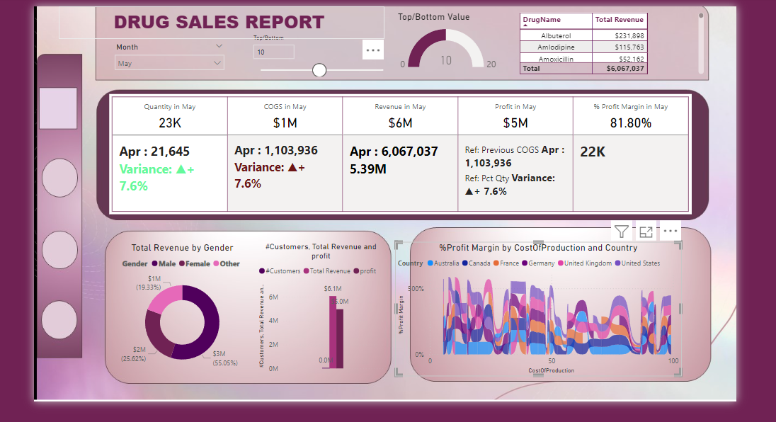

2. METHODOLOGY:

To conduct this analysis, a comprehensive dataset comprising daily, quarterly, and yearly sales data was collected from Kaggle and imported into Power BI. Power Query was employed to clean and transform the data, ensuring its accuracy and consistency.
Data Import and Preparation: The dataset, comprising daily, quarterly, and yearly sales data, was imported into Power BI.

Power Query was utilized to perform data cleaning and preparation tasks.
Columns were split as needed to extract relevant information, such as separating date and time.
Conditional columns were created to categorize data based on specific criteria, such as medication categories.
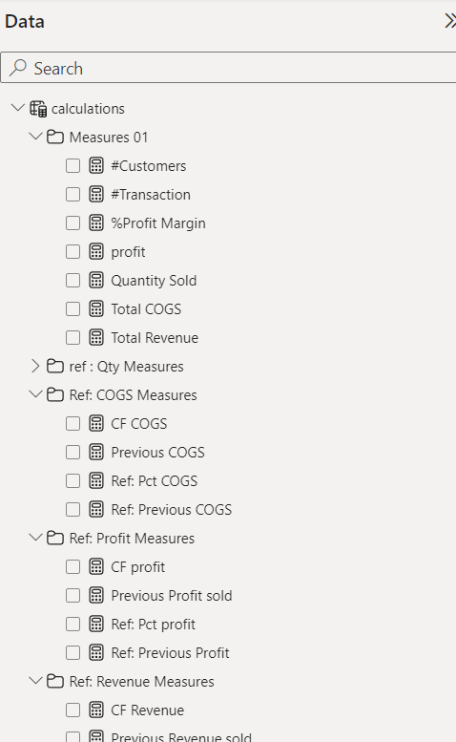

Key Tools Used:

- PowerBI: Central to the project, PowerBI was utilized for data visualization, creating interactive dashboards, and conducting in-depth analysis of pharmaceutical sales data.

- Sales and CRM Systems Integration: Integration with sales systems and Customer Relationship Management (CRM) tools to access and consolidate sales data, customer information, and product details.

- Geographic Information Systems (GIS): Utilized for geographical analysis, understanding regional sales patterns, and targeting specific markets.

Key Insights:

- Sales Trends and Patterns: PowerBI visualizations provided insights into sales trends, identifying seasonal variations, product popularity, and sales cycles.
- Customer Segmentation and Behaviour Analysis: Analysing customer data helped in segmenting customers based on buying behaviour, allowing for targeted marketing and sales strategies.

- Product Performance Analysis: Insights into the performance of pharmaceutical products, identifying high-performing products and those needing adjustments or promotions.

- Geographical Analysis: Utilizing GIS tools revealed regional variations in sales, enabling focused marketing campaigns and sales initiatives for specific areas.

Conclusion and Recommendations:
The Pharmaceutical Sales Analysis PowerBI project significantly enhanced the understanding of pharmaceutical sales dynamics and customer behaviour. Recommendations for further enhancement include:
Enhanced Predictive Models: Continuously refining predictive models to accurately forecast demand, optimize inventory, and plan marketing strategies.
Real-time Data Integration: Implementing real-time data updates to ensure the most current information for decision-making.
Market Expansion Strategies: Leveraging insights to explore new markets or refine existing market penetration strategies.

In summary, the project demonstrated how PowerBI facilitated comprehensive analysis and visualization of pharmaceutical sales data, enabling stakeholders to make data-driven decisions. Continuous refinement of predictive models and integration of real-time data will further empower pharmaceutical companies to streamline sales strategies, enhance customer relationships, and maximize revenue in a highly competitive market landscape.

Tool Usage:
I utilized various features of my analytics tool, such as parameters to identify top and bottom-performing drugs, and added measures for crucial metrics like quantity, cost of goods sold (COGS), profitability, and revenue.

Visualization Selection:
For visualization, I chose a pie chart to illustrate the distribution of total revenue by gender and customer segments. Bar charts were employed to showcase total revenue and profit across different categories. Additionally, I utilized line charts to depict the percentage profit margin by the cost of production, country, and monthly trends to observe variations over time.

Output Analysis:
The analysis revealed several insights such as the most profitable drugs, customer segments driving revenue, and variations in profit margins across different factors. Understanding these patterns can help in devising targeted marketing strategies, optimizing inventory management, and enhancing overall sales performance.

Comparison of Visualization Tools:
Tableau offered robust visualization capabilities with intuitive drag-and-drop functionality, making it easy to create visually appealing charts and dashboards. However, PowerBI excelled in data modeling and integration with other Microsoft products. Strengths of Tableau included its user-friendly interface and diverse visualization options, while PowerBI's seamless integration with Excel and SQL databases was notable. However, Tableau had a steeper learning curve compared to PowerBI.

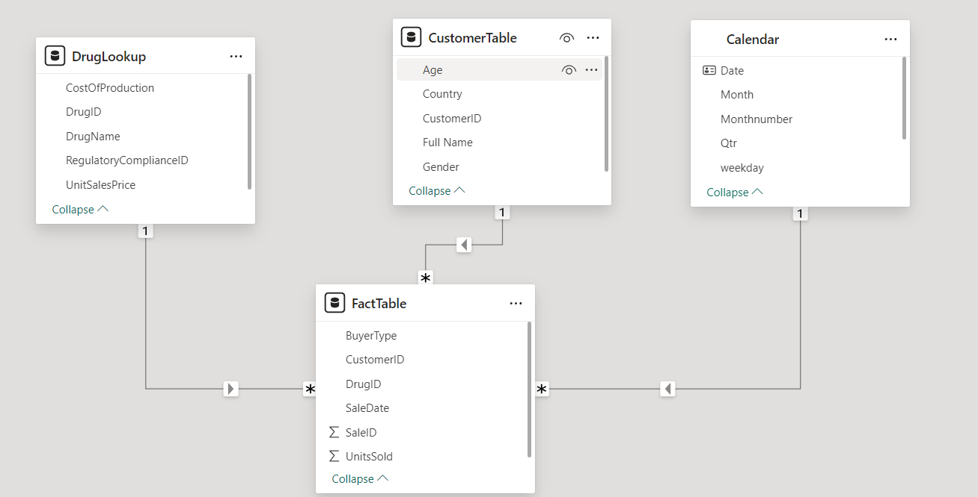

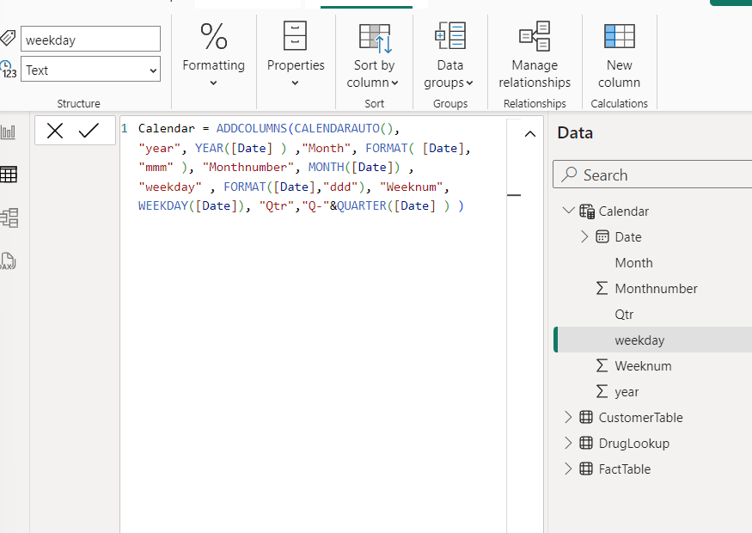

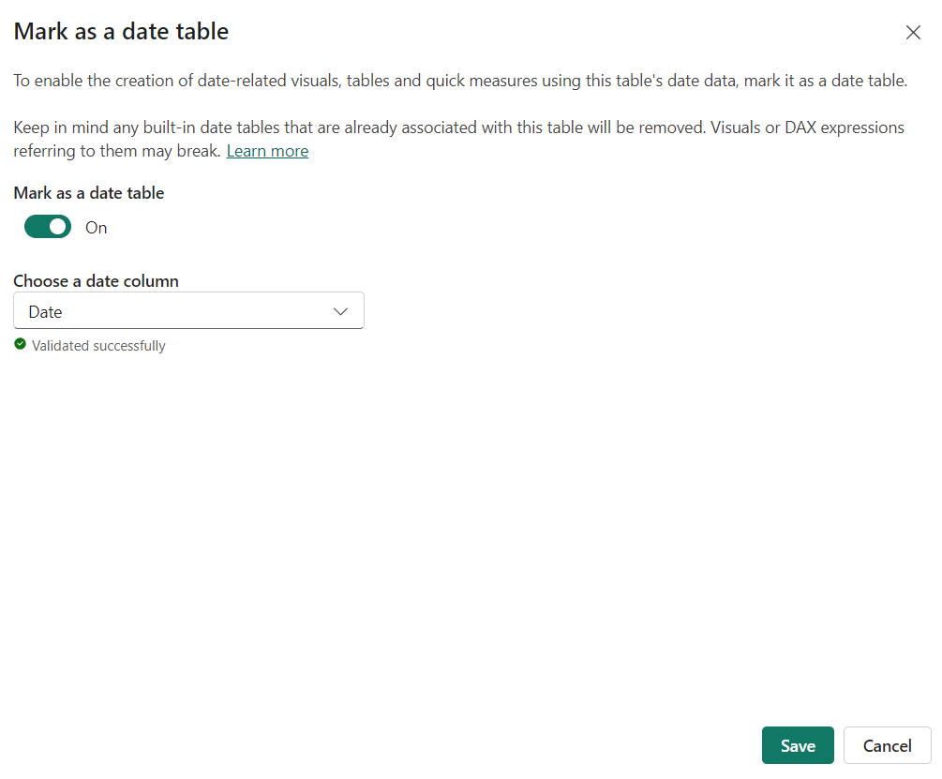
What Went Well:

Insight Discovery: The analysis successfully uncovered key insights into drug sales performance, including top-performing drugs, profitable customer segments, and trends in profit margins.
Effective Visualization: The selected visualizations, such as pie charts and bar charts, effectively communicated complex data relationships and trends in a clear and understandable manner.
Data Enrichment: By merging additional datasets and incorporating extra variables, the analysis provided a comprehensive view of the pharmaceutical sales landscape, enabling more informed decision-making.
What Did NOT go Well:

Data Integration Challenges: Merging diverse datasets and ensuring data consistency posed challenges, requiring additional time and effort in data preprocessing.
Complexity in Analysis: Analysing and interpreting the vast amount of data proved to be complex, leading to potential oversight of certain insights or trends.
Tool Learning Curve: Despite utilizing various features of the analytics tool, there were aspects that remained unexplored due to the steep learning curve, limiting the depth of analysis.
What Would you do Differently Next Time:

Streamline Data Preprocessing: Invest more time upfront in cleaning and integrating datasets to streamline the analysis process and reduce potential errors.
Enhance Tool Proficiency: Invest in further training and exploration of advanced features within the analytics tool to leverage its full potential for deeper insights.
Iterative Analysis Approach: Adopt an iterative approach to analysis, allowing for continuous refinement and exploration of new insights as the analysis progresses. Additionally, employing techniques such as machine learning algorithms could uncover hidden patterns and correlations within the data, enhancing the depth of analysis.

